1. (0.4 points) (Remember that input values which do not occur are “Don’t Cares.”)
Show truth tables for each of the following: The system has four inputs, a, b, c, and d, and one output, f. The last three inputs (b, c, d) represent a binary number, n, in the range 0 to 7; however, the input 0 never occurs. The first input (a) specifies which of two computations is made.
a = 0: f is 1 iff n is a multiple of 2
a = 1: f is 1 iff n is a multiple of 3.
a | b | c | d | f
0 | 0 | 0 | 0 | X
0 | 0 | 0 | 1 | 0
0 | 0 | 1 | 0 | 1
0 | 0 | 1 | 1 | 0
0 | 1 | 0 | 0 | 1
0 | 1 | 0 | 1 | 0
0 | 1 | 1 | 0 | 1
0 | 1 | 1 | 1 | 0
1 | 0 | 0 | 0 | X
1 | 0 | 0 | 1 | 0
1 | 0 | 1 | 0 | 0
1 | 0 | 1 | 1 | 1
1 | 1 | 0 | 0 | 0
1 | 1 | 0 | 1 | 0
1 | 1 | 1 | 0 | 1
1 | 1 | 1 | 1 | 0

2. (0.4 points) For each of the following expressions, indicate which (if any) of the following apply (more than one may apply):
i. Product term
ii. SOP expression
iii. Sum term
iv. POS expression
c. b’c’d’
(i), (ii), and (iv) applies.
e. a’+ b
(ii), (iii), and (iv) applies.

3. (0.4 points) Using properties 1 to 10, reduce the following expressions to a minimum SOP form. Show each step (number of terms and number of literals in minimum shown in parentheses).
b. x’y’z’ + x’yz + xyz (2 terms, 5 literals)
$x’y’z’ + (x’+x)yz$ P8a.
$x’y’z’ + yz$ P5a., P3b.

c. x’y’z’ + x’y’z + xy’z + xyz’ (3 terms, 7 literals)
$x’y’(z + z’) + xy’z + xyz’$ P8a.
$x’y’ + xy’z + xyz’$ P5a.P3b.
$y’(x’ + xz) + xyz’$ P8a.
$y’(x’ + z) + xyz’$ P10a.
$y’x’ + y’z + xyz’$ P8a.

g. x’y’z’ + x’y’z + x’yz + xy’z + xyz + xyz’ (3 terms, 5 literals)
$x’y’(z+z’) + x’yz + xy’z + xy(z+z’)$ (P8a.)*2
$x’y’ + x’yz + xy’z + xy$ P5a., P3b.
$y(x’z + x) + x’y’ + xy’z$ P8a.
$y(x + z) + y’(x’ + xz)$ P10a., P8a.
$yx + yz + y’(x’ + z)$ P8a., P10a.
$yx + yz + y’x’ + y’z$ P8a.
$z(y’ + y) + yx + y’x’$ P8a.
$z + yx + y’x’$ P5a., P3b.

4. (0.4 points) Show a block diagram of a system using AND, OR, and NOT gates to implement the following functions. Assume that variables are available only uncomplemented. Do not manipulate the algebra.
b. ab + c(a + b)
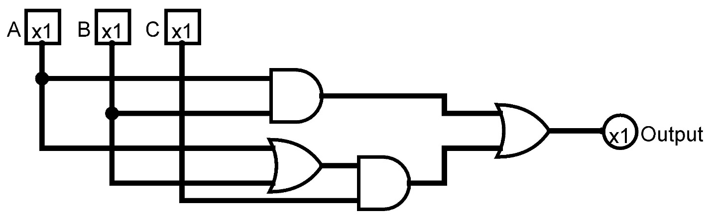

5. (0.4 points) For each of the following circuits,
i. find an algebraic expression.
ii. put it in sum of product form.
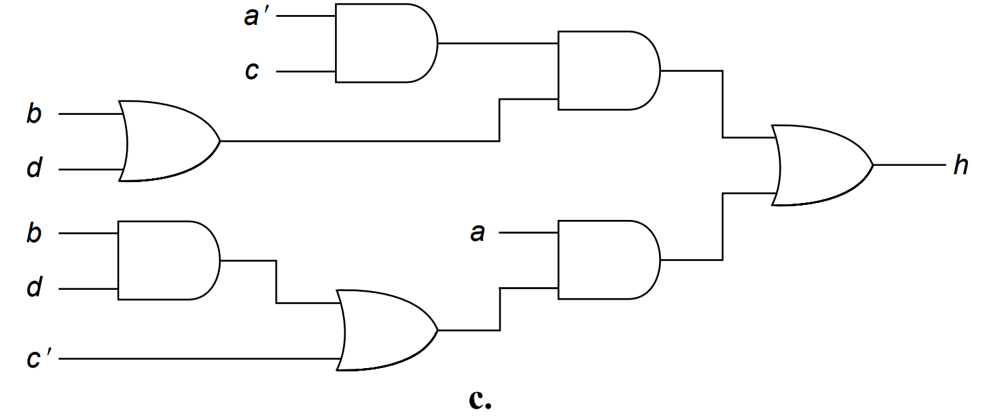
- $a’∙c∙(b+d)+a∙(c’+b∙d)$
- $a’cb + a’cd + ac’ + abd$

6. (0.4 points) Find the complement of the following expressions. Only single variables may be complemented in the answer.
c. h = (a + b)(b’ + c) + d’(a’b + c)
$h’={\left(\left(a + b\right)\left(b’ + c\right)\right)}^{'}*{\left(d’\left(a’b + c\right)\right)}^{'}$ P11b
$h’ =\left({\left(a + b\right)}^{'} + \left(b’ + c\right)’\right)*({\left(d^{'}\right)}^{'}+{\left(a^{'}b+c\right)}^{'})$ P11b., P11b.
$h’ = \left(a^{'}b^{'}+{\left(b^{'}\right)}^{'}*c'\right)*{\left(d+{(a}^{'}b\right)}^{'}*c')$ P11a., P11a., P7., P11a.
$h’ = \left(a^{'}b^{'}+b*c'\right)*\left(d+\left(\left({\left(a^{'}\right)}^{'}+b^{'}\right)*c^{'}\right)\right)$ P7., P11b.
$h’ = \left(a^{'}b^{'}+bc'\right)*\left(d+c^{'}\left(a+b^{'}\right)\right)$ P7.

7. (0.4 points) For each of the following functions:
1. f(x, y, z)=∑m(1, 3, 6)
2. g(x, y, z)=∑m(0, 2, 4, 6)
a. Show the truth table.
b. Show an algebraic expression in sum of minterms form.
c. Show a minimum SOP expression (1: 2 terms, 5 literals; 2: 1 term, 1 literal).
1a) 2a)
x | y | z | f
0 | 0 | 0 | 0
0 | 0 | 1 | 1
0 | 1 | 0 | 0
0 | 1 | 1 | 1
1 | 0 | 0 | 0
1 | 0 | 1 | 0
1 | 1 | 0 | 1
1 | 1 | 1 | 0
x | y | z | f
0 | 0 | 0 | 1
0 | 0 | 1 | 0
0 | 1 | 0 | 1
0 | 1 | 1 | 0
1 | 0 | 0 | 1
1 | 0 | 1 | 0
1 | 1 | 0 | 1
1 | 1 | 1 | 0

1b) $f\left(x,y,z\right)=x^{'}y^{'}z+x^{'}yz+xyz^{'}$
2b) $g\left(x,y,z\right)=x^{'}y^{'}z^{'}+x^{'}yz^{'}+xy^{'}z^{'}+xyz'$

1c) $f\left(x,y,z\right)=x^{'}y^{'}z+x^{'}yz+xyz^{'}$
$f\left(x,y,z\right)=x^{'}z(y^{'}+y)+xyz^{'}$ P8a
$f\left(x,y,z\right)=x^{'}z+xyz^{'}$ P5a, P3a

2c) $g\left(x,y,z\right)=x^{'}y^{'}z^{'}+x^{'}yz^{'}+xy^{'}z^{'}+xyz'$
$g\left(x,y,z\right)=x^{'}z^{'}\left(y^{'}+y\right)+xz^{'}\left(y+y^{'}\right)$ P8a, P8a
$g\left(x,y,z\right)=x^{'}z^{'}+xz^{'}$ P5a, P3a, P5a, P3a
$g\left(x,y,z\right)=z^{'}\left(x+x^{'}\right)$ P8a
$g\left(x,y,z\right)=z'$ P5a, P3a

8. (0.4 points) For each of the following circuits,
i. find an algebraic expression.
ii. put it in SOP form.
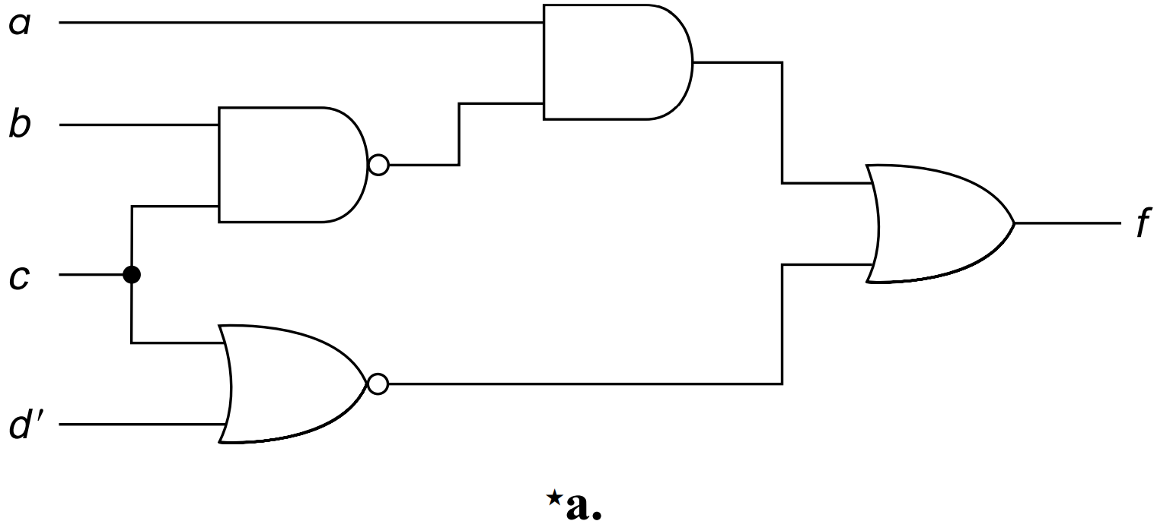
- $f(a,b,c,d) = a(bc)’+(c+d’)’$

- $f\left(a,b,c,d\right)= a\left(b^{'}+c^{'}\right)+\left(c^{'}d\right)$ P11b, P11a
$f\left(a,b,c,d\right)= ab^{'}+ac'+c'd$ P8b

9. (0.4 points) Convert each of the following expressions to sum of products form:
b. (a’ + b + c’)(b + c’ + d)(b’ + d’)
$(a^{'}d+b+c')(b’+d’)$ P8b
$bd^{'}+b'(a^{'}d+c^{'})$ P14b
$b^{'}d+b^{'}c^{'}+b'a'd$ P8a
$$a’b’d+b’c’+bd’$$

10. (0.4 points) Convert each of the following expressions to product of sums form:
b. w’xy’ + wxy + xz
$x(w’y’ + wy + z)$ P8a
$x(z+wy+w')(z+wy+y')$ P8b
$x(z+w'+y)(z+w+y')$ P10a

